

HeartSmart

We are so excited to be able to tell you that we at Hoylake Holy Trinity have recently started to be a HeartSmart School!
HeartSmart is a creative approach that we use to build character, emotional health and resilience in children. Equipping children with foundational principles and skills that will improve their mental health and relationships and academic achievement, at Hoylake Holy Trinity, we want everyone to know that they are loved, cared for and valued. We recognise the value of educating the heart alongside educating the mind.
The Department for Education has announced changes to Relationships and Sex Education (RSE). These changes, it has been confirmed, come into effect from the beginning of the Summer Term 2021 and all schools will be obligated to comply with the updated statutory requirements and we will use HeartSmart as another tool to do just that!.
Introduction to HeartSmart for Parents
Here are some fun phrases that are part of the HeartSmart program and we are sure you'll start hearing them in your home as well. They're called the HeartSmart High Five and here's a brief overview:
The HeartSmart High Five
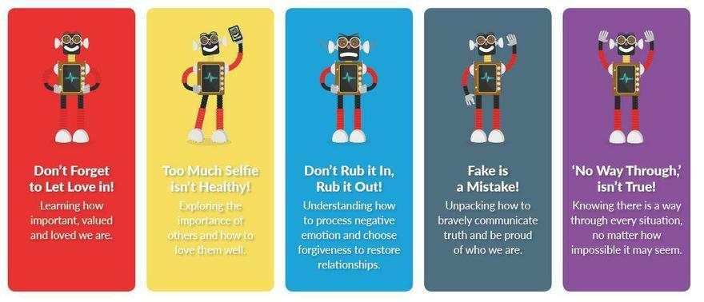


As our school and your child continue their HeartSmart Journey, we will also invite you as a family to come on it too by taking part in HeartSmart Creative! Throughout the year, we will invite you to take part in a creative activities at home to complement activities in school. Science shows that the best way to get information from your head to your heart is to use your hands! We hope that as a family, you enjoy the films and activities in HeartSmart Creative and also learn something new on the way.

Parents introduction to HeartSmart

Follow this link to watch the video.
https://www.youtube.com/watch?v=WI9XpRqJXwQ&feature=youtu.be


As a school we are super excited to really get going on our HeartSmart Journey.

As soon as we settle back onto a more normal routine your child will come home with a password to enable them to access the fantastic resources and activities via the HeartSmart website.


Take this time to watch the video and get excited to begin the HeartSmart adventure.

- Home
- About Us
- Key Information
- News and Events
- Community Events
- Parents

