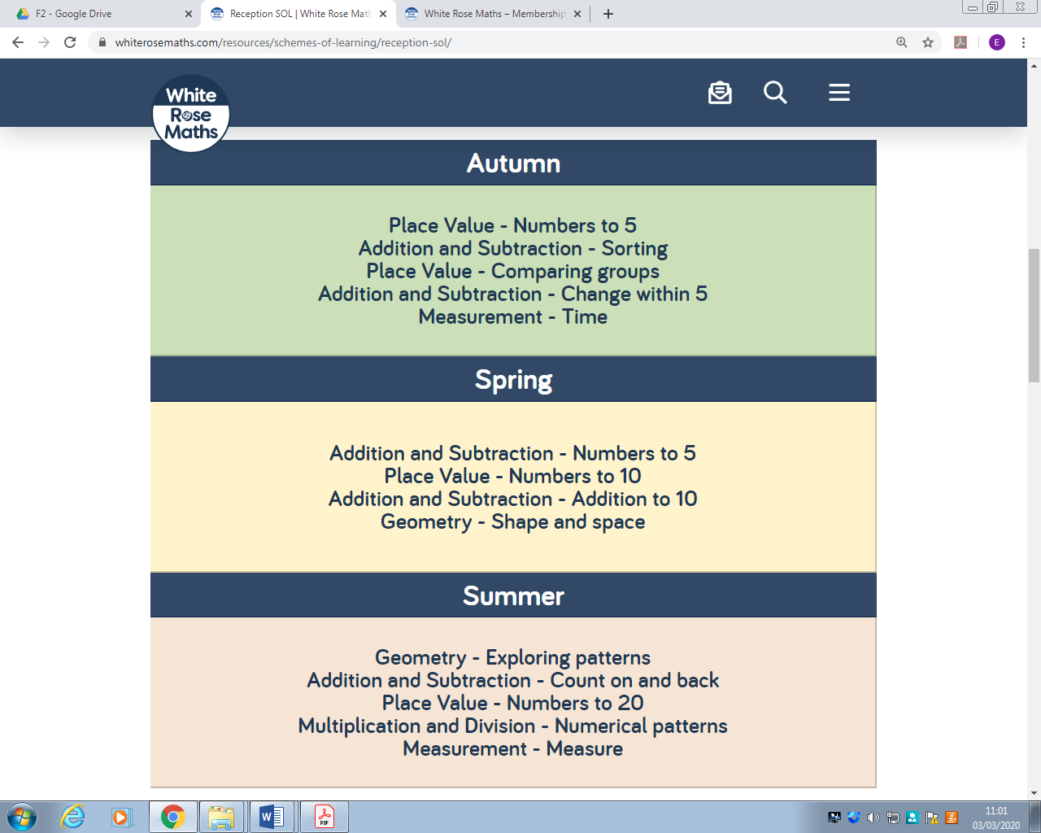


Hoylake Holy Trinity CE Primary – EYFS F2 Maths Long Term Plan

