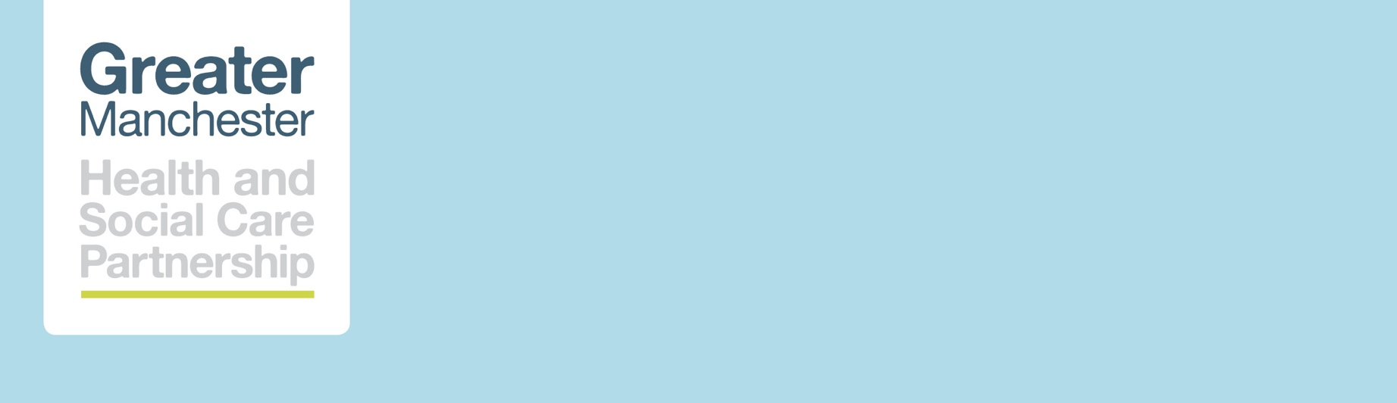

supported by:


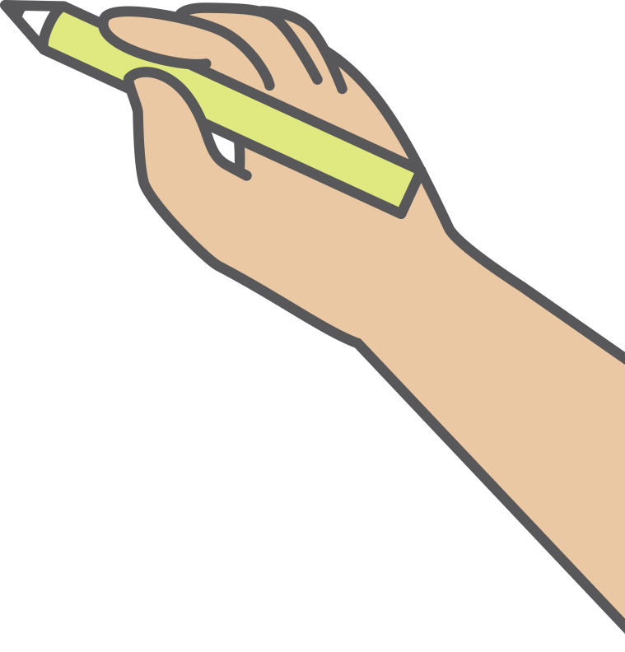
resource pack for schools and
colleges
MAY 2022

exams, stress and anxiety

This resource pack contains key resources that you may find useful for working with and supporting young people and their parents and carers. Unlike the mental health in education packs on the mental health website this pack won’t be updated throughout the year. It will be updated each year with new resources.

Resource | Audience | Document | Summary
Anxiety

What is Anxiety | Young people | 42nd Street  What is Anxiety | Short guide to anxiety and what can help
Anxiety | School staff | Anna Freud  Podcast  youtu.be/H9UaMZ3hLAU | Dr. Peter Fuggle discusses how school staff can support pupils who may be dealing with anxiety.
Anxiety. A guide for young people  - What is anxiety?  - The symptoms of anxiety  - What to do about anxiety  - Treating anxiety  - Tips from our Activists and bloggers on dealing with anxiety  - Real stories from young people  - Where to get help | Young people | Young Minds  Anxiety. A guide for young people | It’s really common to develop anxiety at some point. Find out here what causes it and what you can do to feel better.
Depression

What is Depression | Young people | 42nd Street  What is Depression | Short guide to depression and tools to help
Depression. A guide for young people  - What is depression?  - The symptoms of depression  - What to do about depression  - Treating depression  - Get help now | Young people | Young Minds  Depression. A guide for young people | If you think you might have depression, you're not alone. Find out more about this common, treatable condition and what to do if you're affected by it.
Exam stress

Guide | Young people | Kooth  Guide | A guide to coping with exam stress
Posters | Young people | Kooth  Posters | A set of posters signposting to the service and focusing on exam stress
Exam stress lessons plans for KS3 and 4 | School staff | PHE | In this lesson, students identify the signs and symptoms of exam stress and develop strategies to help them manage it.
Exam Stress | School staff | Anna Freud  Podcast  youtu.be/hOZdqFFxfAU | Dr. Rina Bajaj gives advice to school staff about helping young people deal with exam stress.
Help your child beat exam stress | Parents | NHS  Help your child beat exam stress | Tests and exams can be a challenging part of school life for children and young people and their parents or carers. But there are ways to ease the stress.
Exams | Young people | Anna Freud  youtu.be/VGqDAUZwhas | In this video, Dr. Sheila Redfern gives some simple advice and tips about managing stress around moments such as exams including when waiting to hear the results
Exams  - Dealing with exam stress  - Keep it in perspective  - Revision tips  - Dealing with disappointing exam results  - Get help now | Young people | Young Minds  A guide for young people – exam stress | It is normal to feel a bit worried about exams, especially if you're under pressure from school or family. Exam stress can cause you to feel anxious or depressed, and this might affect your sleeping or eating habits.
Exams – parent guide  - Things that can really help  - How can the school help?  - How to manage a 'disappointing' results day  - Where to get help | Parents | Young Minds  A guide for parents – exams | If you're worried about how your child is coping with exams at school, here is our advice and information on where you can get help
Revision

Revision | Young people | Student room  www.thestudentroom.co.uk/ | The UK's largest online community for students with lots of free advice and guidance, including revision guides, advice on making flashcards or mind maps and a range of top-tips from students themselves including this video about how to cope with exams and revising
Revision | Young people | Student room film  youtu.be/73TCYeEUAOM | Exams and Revision can be a stressful time. So, our vlogger Manisha is here to discuss how she handles her revision and exam stress
Sleep problems

Sleep problems. A guide for young people  - Anxiety and worries  - Nightmares & bad dreams  - Night terrors  - Wetting the bed  - Altered sleep problems  - Get support and tips  - Where to get help | Young people | Young Minds  Sleep problems. A guide for young people | We all have problems with sleeping, waking, or having bad dreams sometimes. If sleep issues are affecting you, we can help you tackle them.
Wellbeing and self-care

My self-care plan secondary | Young people | Anna Freud  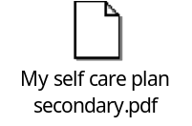 | This resource walks young people through a series of steps, helping them create a detailed self-care plan that works for them.
5 Ways to Wellbeing | Young people | 42nd Street  5 Ways to Wellbeing | Five things that you can do to give your positivity levels a boost and look after your mental health on a regular basis.
Talking mental health with young people at secondary school | Parents and carers | Anna Freud  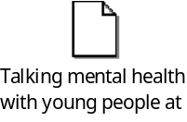 | Provides simple advice and guidance to parents and carers about how to make conversations about their child's feelings part of everyday conversation

GET IN TOUCH
hub.gmhsc.org.uk/mental-health/
e: gmhscp.gmmhprogramme@nhs.net

